CHAPTER 9
Placement Readiness & Career Intelligence Portal
A single view of placement readiness, skill gaps, company fit, and structured upskilling — faculty-reviewed.
Human authority: the placement officer / mentor. Primary output: per-student readiness plan and shortlist.
The 14-Lab Method (Recap)
Every worklet in this book is built the same way: as a coordinator-plus-workers agentic system that is grown, one capability at a time, through 14 hands-on labs. This chapter is self-contained — it restates the method, the node-graph legend and the pseudocode conventions before applying them to this worklet — so it can be handed to a team on its own.
The guiding design principle is constant across all worklets: agents draft and flag; a named human approves. No worklet takes a consequential action autonomously — the human authority named in this chapter signs off before anything is published or sent.
The four phases
Phase | What it establishes
Phase A — Foundations (Labs 1–6) | Turn a single agent loop into a tool-using, skill-driven, memory-backed agent that reaches all data through one connector and runs inside a governed runtime with an audit log.
Phase B — Orchestration (Labs 7–8) | Wire the specialist agents into an explicit node graph, then parallelise the per-unit work and merge the best results.
Phase C — Applied reliability (Labs 9–11) | Ground every output in evidence, make the pipeline self-healing on validation failure, and treat the spec as a tested build.
Phase D — Governance & capstone (Labs 12–14) | Add safety, approval, evaluation and rollback; plug in domain specialists; integrate everything into a deployed, team-owned system.
Reading the node graph
- Navy — the apniLeap AURA Coordinator: owns the run-state, plan, budgets and audit log.
- Light blue — specialist agents, each with one responsibility and a typed message contract.
- Amber — the human review gate: a hard stop; the named human is the final authority.
- Green — governed publish/act: versioned, auditable, reversible.
- Dashed grey — coordinator oversight of every agent; a red back-edge is validation → regenerate.
Pseudocode conventions
- Pseudocode is language-neutral: Coordinator orchestrates; Agent.step(ctx) is one specialist doing its job on the shared run-context; a human gate returns approve / edit / override.
- The blueprint/plan is locked before work begins; validation is a hard gate; the human approves before publish.
9.1 Worklet Overview
Students lack a single view of placement readiness; skill gaps against target roles are not visible until interviews, company-fit is guessed rather than data-driven, and coding practice and mock-interview feedback are scattered.
This worklet proposes a Placement Readiness & Career Intelligence Portal that parses the student's resume and coding-platform activity, benchmarks skills against target-role requirements, scores placement readiness, ranks company and role matches, and generates a personalized learning roadmap with mock-interview practice — turning scattered student data into one auditable, faculty-reviewed readiness picture.
Stakeholders: Students, Placement Cell, Faculty
Problems heard
- Students lack a single view of placement readiness.
- Skill gaps against target roles are not visible until interviews.
- Company-fit is guessed rather than data-driven.
- Coding practice and mock-interview feedback are scattered and not tied to a learning plan.
- There is no consistent, faculty-reviewed readiness score across students.
9.2 Target Final Solution (Definition of Done)
The capstone (Lab 14) is complete when, for a real case, the worklet turns a request into a validated, evidence-grounded per-student readiness plan and shortlist that passes every check, is reviewed and approved by the placement officer / mentor, and is published with a full audit trail — with light human edits, not a rewrite.
Capabilities
Capability | What it means
The | The student uploads a resume and links coding-platform and academic-record accounts, with explicit consent per source.
The | The Resume Agent extracts skills, projects, and experience into a structured profile.
The | The Skill Gap Agent benchmarks the profile against target-role requirements while the Coding Analytics Agent aggregates platform activity, in parallel.
The | The Job Matching Agent computes the placement score and ranks company/role matches with visible confidence and reasoning.
The | The Interview Agent runs mock-interview practice and compiles a learning roadmap.
The | The Placement Cell convener reviews exceptions and low-confidence matches, approves the readiness score, and releases the roadmap and mock-interview plan to the student.
Success metrics (KPIs)
- 100% of validation checks pass before the placement officer / mentor review (e.g. recommendations cite the specific skill gaps).
- Every per-student readiness plan and shortlist is grounded in verified skills and stated role requirements, with an evidence record.
- Zero consequential actions without the placement officer / mentor's approval; a complete audit trail and one-click rollback.
9.3 System at a Glance — the Node Graph
A coordinator-plus-workers system: the apniLeap AURA Coordinator holds the plan, run-state and audit log and drives the pipeline; validation is a hard gate; the human review is a hard stop before publish.
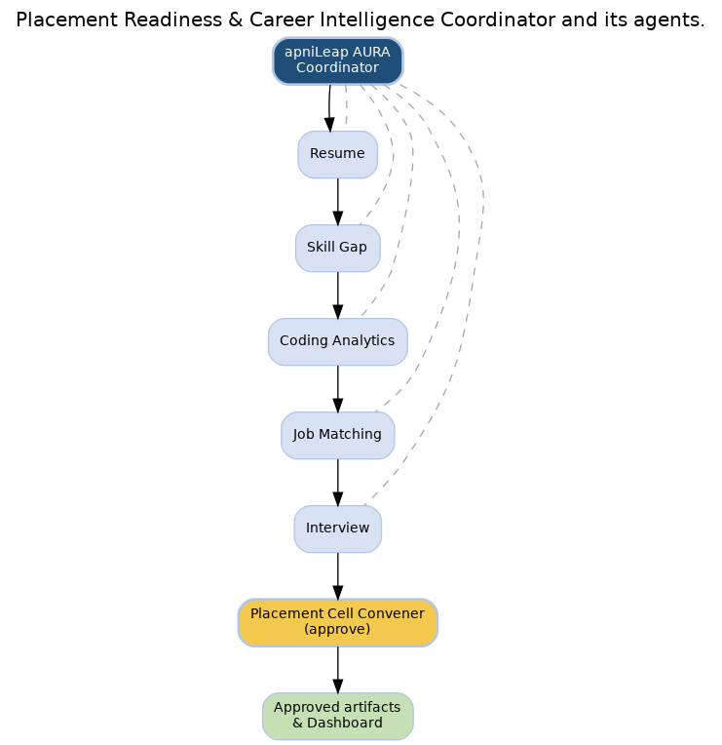
Figure 9 — the Placement Readiness & Career Intelligence Portal agent graph. Amber = human gate; green = governed publish; dashed = coordinator oversight.
End-to-end flow
- The student uploads a resume and links coding-platform and academic-record accounts, with explicit consent per source.
- The Resume Agent extracts skills, projects, and experience into a structured profile.
- The Skill Gap Agent benchmarks the profile against target-role requirements while the Coding Analytics Agent aggregates platform activity, in parallel.
- The Job Matching Agent computes the placement score and ranks company/role matches with visible confidence and reasoning.
- The Interview Agent runs mock-interview practice and compiles a learning roadmap.
- The Placement Cell convener reviews exceptions and low-confidence matches, approves the readiness score, and releases the roadmap and mock-interview plan to the student.
9.4 Agent Roster — Roles, Communication & Guardrails
# | Agent | Role & communication | Guardrails
0 | apniLeap AURA Coordinator | Receives the faculty prompt command, checks permissions, creates the run plan, initializes agents, and monitors state. | Never bypass human approval; enforce data scope, audit logging, source citation, and exception routing.
1 | Resume Agent | Parses the resume and normalizes skills, projects, and experience into structured fields. | Validate consent before parsing personal data; never expose resumes beyond permissions; flag inconsistent entries.
2 | Skill Gap Agent | Compares the profile against target-role benchmarks and placement records. | Use approved benchmarks; cite the source of each; do not label a student unfit without human review.
3 | Coding Analytics Agent | Aggregates coding-platform activity, contest performance, and problem-solving trends. | Pull only from authorized integrations; keep raw submissions private; surface trends rather than raw scores.
4 | Job Matching Agent | Creates the placement score and ranks company/role matches from skill-gap and coding outputs. | Show match confidence and reasoning; do not overstate fit; route low-confidence matches to human review.
5 | Interview Agent | Runs mock-interview practice and compiles a learning roadmap. | Mark AI feedback clearly; keep session recordings private; require faculty sign-off before readiness certification.
6 | Placement Cell Convener Review | Reviews exceptions, approves the score and roadmap, or requests corrections. | Placement Cell decision is final authority for student-facing readiness scores and company matches.
9.5 Agent Interconnections (Message Map)
How the agents are wired — the payloads that flow between them and when. The last rows show the human gate and governed publish.
From | To | Message / payload | When
Coordinator | Resume Agent | run-context + task | run start
Resume Agent | Skill Gap Agent | state / partial result | in pipeline
Skill Gap Agent | Coding Analytics Agent | state / partial result | in pipeline
Coding Analytics Agent | Job Matching Agent | state / partial result | in pipeline
Job Matching Agent | Interview Agent | state / partial result | in pipeline
Interview Agent | Placement Cell Convener Review | state / partial result | in pipeline
Placement Cell Convener Review | The Placement Officer / Mentor gate | draft per-student readiness plan and shortlist + evidence | for review
The Placement Officer / Mentor gate | Coordinator | approve | edit | override | human decision
Coordinator | Governance / Publish | final per-student readiness plan and shortlist (versioned) | on approval
9.6 Data Model
Entity | Key fields
Student profile / resume | Parsed skills, projects, and experience with consent status.
Skill benchmark | Target-role skill requirements and placement records.
Coding analytics | Coding-platform activity, contest performance, and problem-solving trends.
Company/role match | Ranked matches with confidence and reasoning.
Readiness score & roadmap | Placement score and personalized learning roadmap, pending approval.
9.7 Solution Paradigm — Pseudocode
Orchestrator (the whole run)
function run_placement_readiness_career_intelligence_(request):
ctx = Coordinator.new_run(request) # isolated, checkpointed
plan = Coordinator.build_plan(request) # locked before work begins
ctx = ResumeAgent.step(ctx, plan)
ctx = SkillGapAgent.step(ctx, plan)
ctx = CodingAnalyticsAgent.step(ctx, plan)
ctx = JobMatchingAgent.step(ctx, plan)
ctx = InterviewAgent.step(ctx, plan)
ctx = PlacementCellConvenerReview.step(ctx, plan)
report = ValidationAgent.validate(ctx, plan) # hard gate
while not report.passed and attempts < MAX: # self-healing (Lab 10)
Coordinator.regenerate(report.failing); report = validate(ctx, plan)
draft = assemble(ctx) # the per-student readiness plan and shortlist
decision = TheGate.review(draft) # HUMAN — final authority
if decision.approved:
final = apply(decision.edits, draft)
Governance.publish(final, version=next()); Audit.log_all()
return final

Validation (the acceptance gate)
function ValidationAgent.validate(ctx, plan):
checks = [
('recommendations cite the specific skill gaps', test_0(ctx, plan)),
('eligibility rules are enforced', test_1(ctx, plan)),
('no application is submitted without the studen', test_2(ctx, plan)),
('shortlisting is checked for bias', test_3(ctx, plan)),
]
failing = [n for n,ok in checks if not ok]
return Report(passed = not failing, failing = failing,
diagnosis = explain(failing))

Connector (one governed surface for all sources)
connector.expose:
read('student profiles & resumes')
read('job/role requirements')
read('skill-assessment results')
agents.use(connector) # no agent touches a source directly

Worked example — one student, end to end
How a single student travels through the pipeline, from plan to a validated, approved and published per-student readiness plan and shortlist. This is the level of traceability every student should have.
Stage | What happens
Plan / slot | The coordinator locks the plan and picks one student to work — its constraints fixed before any content is chosen.
Source candidate | A retrieval agent proposes a candidate for this student from student profiles & resumes, with provenance.
Grounded candidate | A generation agent produces a fresh candidate grounded in verified skills and stated role requirements, attaching an evidence record (source, scope, tags).
Screen & select | Candidates are calibrated and screened; the best-aligned one that satisfies the plan is selected, the rest logged.
Validation | The result is checked (recommendations cite the specific skill gaps; no application is submitted without the student's consent); on failure only this student is regenerated.
Human review | The Placement Officer / Mentor sees the draft per-student readiness plan and shortlist with its evidence and validation report, and approves, edits or overrides.
Publish & audit | On approval the governed publish versions the per-student readiness plan and shortlist, records the audit trail, and updates history for future runs.
9.8 Hybrid Execution Methodology
How the coordinator runs each stage — what is human-gated, what runs in parallel, what is sequential.
Stage | Execution mode & coordinator behavior
Gate 1: profile intake | Sequential — start only after the Resume Agent has a validated, consented profile.
Parallel build | Parallel — Skill Gap Agent benchmarks the profile while Coding Analytics Agent aggregates activity.
Join and scoring | Sequential — Job Matching Agent runs after both the skill-gap report and coding analytics are available.
Interview and roadmap | Sequential — the roadmap is built once ranking is confirmed.
Placement Cell approval | Sequential — the score and roadmap are approved before release; corrections route back.
Dashboard update | Parallel after approval — score, skill gaps, matches, and roadmap publish together.
9.9 Dashboard Template
What the placement officer / mentor sees to review, approve and monitor.
Panel | Shows
Readiness score | Placement score with the signals that drove it.
Skill gaps | Gaps against target roles with cited benchmarks.
Company matching | Ranked matches with confidence and reasoning.
Learning roadmap | Personalized upskilling steps and mock-interview plan.
9.10 The 14-Lab Evolution
Each lab is a working increment that adds one capability to this worklet and activates specific nodes. Ship the deliverable and pass acceptance before advancing — by Lab 14 they compose into the deployed per-student readiness plan and shortlist system.
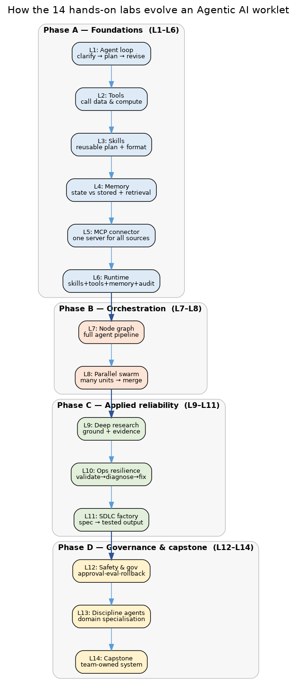
Lab 1 — Agent vs Chatbot — the per-student readiness plan and shortlist planner loop
Phase: A · Foundations Goal: Establish the agent loop (clarify → plan → revise) instead of a one-shot chatbot answer.
What it adds to this worklet. A minimal planner that clarifies the request, proposes a plan for producing the per-student readiness plan and shortlist, and revises on feedback — the seed this worklet grows from.
Inputs | Outputs | Agents / nodes | Deliverable & acceptance
Free-text request; core parameters. | A clarified request + an editable outline plan for the per-student readiness plan and shortlist. | Coordinator (loop only). | A notebook agent that clarifies, plans and revises a per-student readiness plan and shortlist outline. Accept: Given a vague request it asks at least two clarifying questions and yields a coherent, editable plan.
Nodes activated. Coordinator loop (no specialist nodes yet).
Pitfall to avoid. Don't answer in one shot — without clarify/revise it's a chatbot, not an agent.
Lab 1 — plan & revise
req = clarify(user_request) # ask until inputs complete
plan = propose_plan(req) # outline for the per-student readiness plan and shortlist
while user.wants_changes(plan): plan = revise(plan, user.feedback)
return plan # not final — a structured plan

Lab 2 — Tool-Using Agent — call data & compute
Phase: A · Foundations Goal: Give the agent tools it must call to act, rather than answering from memory.
What it adds to this worklet. Readers for student profiles & resumes and job/role requirements, plus a domain calculator/checker, so the planner acts on real data.
Inputs | Outputs | Agents / nodes | Deliverable & acceptance
student profiles & resumes; job/role requirements; parameters. | Verified computed values and parsed inputs. | Coordinator + tool layer. | An agent that reads student profiles & resumes and computes/validates through typed tools. Accept: Key numbers and lookups always go through tools, never hand-done in the prompt.
Nodes activated. Tool layer feeding the early data agents.
Pitfall to avoid. Never assert a fact in the prompt that a tool should verify.
Lab 2 — typed tools
a = tool.read('student profiles & resumes')
b = tool.read('job/role requirements')
v = tool.compute(a, b)
assert v.valid

Lab 3 — Skill Creation — reusable plan & format skills
Phase: A · Foundations Goal: Package repeatable capability as reusable, schema-typed skills.
What it adds to this worklet. A plan/blueprint skill and a formatting skill that renders the per-student readiness plan and shortlist — both reusable across cases.
Inputs | Outputs | Agents / nodes | Deliverable & acceptance
Parsed inputs; template spec. | A locked plan object; a formatted per-student readiness plan and shortlist shell. | Planning and assembly emerge as skills. | Two callable skills with schemas, invoked by the agent. Accept: The same skill works for two different cases without code changes.
Nodes activated. Plan node + Assembly node (as skills).
Pitfall to avoid. Keep skills case-agnostic and typed; hard-coding one case breaks reuse.
Lab 3 — skill interface
skill plan(inputs) -> Plan: return expand(inputs).lock()
skill format_per(result, template) -> Document

Lab 4 — Memory & Retrieval — state vs stored
Phase: A · Foundations Goal: Separate short-term run state from long-term stored knowledge.
What it adds to this worklet. Session state (the current draft) vs stored reference — student profiles & resumes and the history of past students — retrieved by tags and by similarity.
Inputs | Outputs | Agents / nodes | Deliverable & acceptance
student profiles & resumes; history of prior students; current draft. | Tag- and similarity-based retrieval. | Retrieval agent; foundations of later screening. | Retrieval over the store + history with tag filters and embedding similarity. Accept: For a given task, retrieval returns correctly-tagged candidates and similar prior items.
Nodes activated. Retrieval node; seeds validation/no-repeat.
Pitfall to avoid. Don't conflate run state with the archive — mixing them corrupts the baseline.
Lab 4 — memory split
state.draft = candidate # short-term
hits = retrieve(store, tags) # long-term
prior = retrieve(history, embed(candidate), k=5) # similarity

Lab 5 — MCP-Style Connector — one server for all sources
Phase: A · Foundations Goal: Expose every data source through one typed connector.
What it adds to this worklet. A single connector fronting student profiles & resumes, job/role requirements and skill-assessment results so every agent reaches data the same governed way.
Inputs | Outputs | Agents / nodes | Deliverable & acceptance
The worklet's data sources. | A uniform, typed tool surface. | Connector used by all data-facing agents. | A connector server with typed endpoints and auth; agents call only through it. Accept: All data access goes through the connector; swapping a source needs no agent change.
Nodes activated. Connector under the data agents.
Pitfall to avoid. No agent should touch a source directly; a bypass defeats governance later.
Lab 5 — connector
connector.expose:
read('student profiles & resumes')
read('job/role requirements')
read('skill-assessment results')
agents.use(connector) # no agent touches a source directly

Lab 6 — Runtime — skills, tools, memory, audit
Phase: A · Foundations Goal: Run the agent inside a controlled runtime with a full audit log.
What it adds to this worklet. A runtime binding skills + tools + memory behind the loop, enforcing budgets and approval gates and logging every step — the backbone later labs plug into.
Inputs | Outputs | Agents / nodes | Deliverable & acceptance
Skills (Lab 3), connector (Lab 5), memory (Lab 4). | A governed run with audit + checkpoints. | Coordinator hardened into the runtime controller. | Runtime wrapping the agent: budgets, gates, checkpoint/resume, audit log. Accept: Every action is logged with inputs/outputs; a crashed run resumes from its last checkpoint.
Nodes activated. Coordinator runtime around all nodes.
Pitfall to avoid. Log inputs and outputs, not just messages; checkpoint before risky steps or resume loses state.
Lab 6 — controlled loop
run = Runtime(budget=B, gates=[publish])
for step in agent.loop():
audit.log(step.intent, step.action, step.result)
if step.risky: wait_for_approval(step)
checkpoint(run.state)

Lab 7 — Agentic Node Graph — the full pipeline
Phase: B · Orchestration Goal: Wire the specialist agents into one explicit graph with state and branching.
What it adds to this worklet. The complete pipeline as a node graph: Resume Agent, Skill Gap Agent, Coding Analytics Agent → … → the placement officer / mentor gate → publish, with a validation → regenerate back-edge.
Inputs | Outputs | Agents / nodes | Deliverable & acceptance
All Phase-A skills/agents. | An executable graph producing a first end-to-end draft. | All core agents connected (see this chapter's node graph). | A graph runner that produces a full per-student readiness plan and shortlist draft end to end. Accept: One command yields a validated per-student readiness plan and shortlist draft end to end.
Nodes activated. All core nodes + the back-edge.
Pitfall to avoid. Bound the retry edge — an unbounded regenerate loop can spin forever.
Lab 7 — graph
graph.chain(ingest -> plan -> workers -> validate)
graph.edge(validate --fail--> workers) # bounded retry
graph.edge(validate --pass--> assemble -> gate -> publish)

Lab 8 — Parallel Swarm — many students, then merge
Phase: B · Orchestration Goal: Parallelise the per-unit work and select the best.
What it adds to this worklet. Several worker agents process students in parallel; a merge/selector picks the best per the plan — cutting latency and improving quality.
Inputs | Outputs | Agents / nodes | Deliverable & acceptance
Locked plan; per-unit work items. | Best-of-N results merged into one compliant output. | Parallel workers + a Merge selector under the Coordinator. | A fan-out/fan-in that processes all units and merges by alignment to the plan. Accept: Parallel run matches or beats sequential quality at lower wall-clock time.
Nodes activated. Parallel worker fan-out + merge.
Pitfall to avoid. Merge strictly by plan alignment; picking the 'nicest' output quietly breaks coverage.
Lab 8 — fan-out/in
results = parallel_map(process_student, plan.units)
output = merge(results, key=alignment_to(plan))

Lab 9 — Deep Research — ground & evidence
Phase: C · Applied reliability Goal: Ground every output in cited, in-scope evidence.
What it adds to this worklet. For each student the agent builds an evidence record grounded in verified skills and stated role requirements, so validity is auditable and out-of-scope content can't slip through.
Inputs | Outputs | Agents / nodes | Deliverable & acceptance
verified skills and stated role requirements; candidate outputs. | An evidence record per unit; a paper-level evidence table. | Generation + grounding step feeding Validation. | Each candidate carries an evidence record; an evidence table is produced. Accept: Every output maps to an in-scope source; ungrounded candidates are rejected.
Nodes activated. Grounding step into the validation check.
Pitfall to avoid. Require a real source; a plausible-sounding but ungrounded item must be rejected, not kept.
Lab 9 — grounding
for c in candidates:
ev = research(c, source='verified skills and stated role requirements')
if not ev.in_scope: reject(c)
c.evidence = ev

Lab 10 — Ops Resilience — validate, diagnose, fix
Phase: C · Applied reliability Goal: Make the pipeline self-healing when validation fails.
What it adds to this worklet. When a check fails (recommendations cite the specific skill gaps; eligibility rules are enforced), the agent diagnoses the exact failing constraint and regenerates only the offending part.
Inputs | Outputs | Agents / nodes | Deliverable & acceptance
Validation report; current output. | A repaired, passing output with a diagnosis log. | Validation agent + Coordinator's regenerate loop. | Failure-injection tests showing automatic diagnosis and targeted repair. Accept: Injected faults are detected and fixed within the retry budget.
Nodes activated. Validation node + self-healing loop.
Pitfall to avoid. Regenerate only the failing part — rebuilding everything wastes budget and churns good work.
Lab 10 — diagnose & fix
report = validate(output, plan)
while not report.passed and attempts < BUDGET:
regenerate(report.failing); report = validate(output, plan)
if not report.passed: escalate(report) # to the human

Lab 11 — SDLC Factory — spec → tested output
Phase: C · Applied reliability Goal: Treat the plan as a spec and the output as a tested implementation.
What it adds to this worklet. The worklet becomes a factory: plan in, a per-student readiness plan and shortlist out that provably passes an automated acceptance suite before the placement officer / mentor sees it.
Inputs | Outputs | Agents / nodes | Deliverable & acceptance
The locked plan (spec); the acceptance suite. | A result plus a green test report. | Validation as the test harness; Coordinator as the build. | A 'build' command: plan → per-student readiness plan and shortlist + passing acceptance report. Accept: No per-student readiness plan and shortlist advances to the placement officer / mentor without a fully passing acceptance report.
Nodes activated. Validation gates the whole graph.
Pitfall to avoid. The acceptance suite is the gate; never let a result skip to the human without a green report.
Lab 11 — spec→artifact
artifact = build(plan) # graph run (Lab 7/8/10)
report = acceptance_suite(artifact, plan)
require report.all_pass # gate before human review

Lab 12 — Safety & Governance — approval, eval, rollback
Phase: D · Governance & capstone Goal: Add confidentiality, approval, evaluation and rollback.
What it adds to this worklet. Access control and confidentiality, the the placement officer / mentor approval gate as a hard stop, evaluation metrics, versioning and one-click rollback.
Inputs | Outputs | Agents / nodes | Deliverable & acceptance
Draft-vs-approved states; role permissions; metrics. | A governed, reversible release. | Governance & Audit agent; the human gate formalised. | Approval workflow + metrics + rollback, with confidentiality controls. Accept: Only the placement officer / mentor-approved results publish; any release rolls back cleanly.
Nodes activated. Human gate + governance node.
Pitfall to avoid. Confidentiality and rollback are requirements, not extras.
Lab 12 — governed release
require actor.can_approve and out.status=='draft'
final = apply(human.edits, out); final.status='approved'
governance.publish(final, version=v+1); metrics.record(...)
on rollback(v): restore(version=v)

Lab 13 — Discipline-Specific Agents — domain specialisation
Phase: D · Governance & capstone Goal: Specialise the worklet to its domain variants.
What it adds to this worklet. Pluggable specialists — role-family packs (software, core, analytics, higher studies) — so outputs match the specific style and constraints of each case.
Inputs | Outputs | Agents / nodes | Deliverable & acceptance
Domain profile; the work item. | Domain-appropriate outputs with correct schemes. | Specialist plugged into the generation node. | A specialist producing domain-correct per-student readiness plan and shortlists. Accept: Specialist outputs use valid domain patterns and produce checkable results.
Nodes activated. Specialist into the generation node.
Pitfall to avoid. Every specialist output needs a checkable scheme; clever but vague outputs are unusable.
Lab 13 — specialist plug-in
specialist = registry.get(domain)
out = specialist.generate(item)
GenerationAgent.use(specialist)

Lab 14 — Capstone — team-owned system
Phase: D · Governance & capstone Goal: Integrate everything into a deployed, team-owned system.
What it adds to this worklet. The full worklet: connector + runtime + node graph + parallel work + grounding + self-healing + governance + specialists, with a the placement officer / mentor dashboard — delivered and demoed end to end.
Inputs | Outputs | Agents / nodes | Deliverable & acceptance
All prior lab deliverables. | A deployed worklet: request → approved, published per-student readiness plan and shortlist. | All agents under the Coordinator (this chapter's node graph). | Deployed system + the placement officer / mentor dashboard + audit trail + a demo on a real case. Accept: The Placement Officer / Mentor produces an approved, validated per-student readiness plan and shortlist in one session.
Nodes activated. Every node, deployed.
Pitfall to avoid. Integrate, don't rewrite — if the labs kept the contracts, the capstone is wiring.
Lab 14 — end-to-end
system = deploy(connector, runtime, graph, governance)
artifact = system.run(request) # the per-student readiness plan and shortlist
dashboard.show(artifact, metrics, audit)

9.11 Reference Architecture, Pilot & MVP
Reference architecture
- Data capture: resume uploads, coding-platform integrations, academic records with consent.
- Data layer: canonical schema for profile, benchmarks, coding analytics, matches, and roadmap.
- AI layer: resume parsing, skill benchmarking, coding-trend analysis, company matching.
- Workflow layer: Placement Cell review queue, roadmap generation, dashboard.
- Governance layer: consent, per-student confidentiality, match-confidence disclosure, audit log.
Pilot artifacts
- A resume/profile intake form.
- A skill-gap benchmark library for 5–8 target roles.
- A coding-analytics connector.
- A placement score dashboard with an exportable learning roadmap.
Suggested MVP roadmap
Order | Capability | What it delivers | Agents involved
1 | Resume parsing | Structured profile from resume with consent. | Coordinator, Resume Agent.
2 | Skill gap + coding analytics | Benchmark skills and aggregate coding activity. | Skill Gap, Coding Analytics Agents.
3 | Placement scoring & matching | Readiness score and ranked company matches. | Job Matching Agent.
4 | Interview & roadmap | Mock-interview practice and learning roadmap. | Interview Agent.
5 | Placement Cell approval | Review and release student-facing outputs. | Placement Cell Convener Review.
6 | Readiness dashboard | Score, gaps, matches, and roadmap in one view. | Coordinator.
Risks & mitigations
Risk | Why it matters | Mitigation (where handled)
Plan drift | individual results deviate from the locked plan | Lock the plan (Lab 3/7); validation rejects any deviation before the human sees it.
Ungrounded output | content not backed by verified skills and stated role requirements | Grounded generation with an evidence record per unit (Lab 9); ungrounded items are rejected.
Failed checks slip through | a result violates a rule (recommendations cite the specific skill gaps) | Validation is a hard gate (Lab 10/11); failing results are diagnosed and regenerated, never advanced.
Runaway loops | the regenerate loop never converges | Bound MAX_ATTEMPTS (Lab 7/10); on exhaustion, escalate to the placement officer / mentor with a diagnosis.
Over-automation | the system acts without the placement officer / mentor | The human gate is a hard stop; all outputs are drafts; edits and overrides are effortless and logged (Lab 12).
9.12 Guardrails, Metrics, Milestones & Glossary
Guardrails
- Do not release a placement score or company match to a student without Placement Cell review.
- Keep skill benchmarks and company requirements current.
- Never expose one student's data to another.
- Validate consent before parsing personal data; keep raw coding submissions private.
- Show confidence and reasoning for matches; route low-confidence matches to human review.
Delivery milestones
Week | Labs | Focus | Exit deliverable
Week 1 | Labs 1–3 | Planner loop, tools, reusable skills | Runnable planner + core skill
Week 2 | Labs 4–6 | Memory/retrieval, connector, governed runtime | Data via connector; audited runs
Week 3 | Labs 7–8 | Full node graph + parallel processing | End-to-end draft — shared with faculty
Week 4 | Labs 9–10 | Grounding + self-healing validation | Grounded output; auto-repair on faults
Week 5 | Labs 11–12 | Tested build + safety/governance | Tested artifact; approval, metrics, rollback
Week 6 | Labs 13–14 | Domain specialisation + capstone | Deployed system + demo on a real case
Checkpoint: from the 3rd week, worklets are shared with all faculty for feedback — plan the Week-3 end-to-end draft (Labs 7–8) to be demo-ready.

Glossary
Term | Meaning
Coordinator | The orchestrator agent that owns run-state, plan, budgets and the audit log.
Node graph | The explicit wiring of agents, gates and back-edges for one worklet.
Human gate | The approval step; the named human is the final authority.
Grounding | Linking an output to a real in-scope source (evidence).
Validation | The automated acceptance gate a result must pass before human review.
Blueprint / plan | The locked specification the pipeline obeys.

